HONG KONG INSTITUTE OF VOCATIONAL EDUCATION
Laboratory 5b: Abstract Class

TASK:
1. Write the supplier classes in the following parts below:
Worker

__name : str
__number_of_workers : int

__init__ (self, name)
get_number_of_workers () : int
__str__ (self) : str
set_salary (self)
get_salary (self)

FTWorker

__monthly_income : float

__init__ (self, name, monthly_income)
set_salary (self, monthly_income)
get_salary (self) : float
PTWorker

CommissionWorker

__commission : float
__quantity : int

__init__ (self, name, commission, quantity)
set_salary (self, commission, quantity)
get_salary (self) : float

HourlyWorker

__wage : float
__hour : float
__init__ (self, name, wage, hours)
set_salary (self, wage, hours)
get_salary (self) : float

(a) Create an abstract class Worker that has:
Attributes:
__number_of_workers – a static variable to store the total number of workers created. Assign this variable to 0 at class level
__name – to store the name of the worker
Methods:
__init__ – initialize the name attribute in worker object. Add 1 to number of workers when a worker object is created
get_number_of_workers – a static method used to return the total number of workers created
__str__ – return a string related to workers as shown in the sample output below
set_salary – an abstract method used to force all child class implement this method. Since the parameters on calculating salaries cannot be determined without more details given
get_salary – an abstract method used to force all child class implement this method. Since the salary of workers cannot be calculated without more details given

(b) Create a class FTWorker inherit from class Worker that has:
Attributes:
__monthly_income – to store the monthly income of the full time worker
Methods:
__init__ – super method call is used to call parent class __init__ method to initialize the name attribute. Call the set_salary method to initialize monthly_income attribute in full time worker object
set_salary – override the parent class set_salary abstract method to initialize the monthly income attribute in full time worker object
get_salary – override the parent class get_salary abstract method to return the monthly income as salary

(c) Create a class PTWorker inherit from class Worker that has empty class body

(d) Create a class CommissionWorker inherit from class PTWoker that has:
Attributes:
__commission – to store the commission of the commission worker
__quantity – to store the number of job performed of the commission worker
Methods:
__init__ – super method call is used to call parent class __init__ method to initialize the name attribute. Call the set_salary method to initialize commission attribute and quantity attribute in commission worker object
set_salary – override the parent class set_salary abstract method to initialize the commission attribute and quantity attribute in commission worker object
get_salary – override the parent class get_salary abstract method to return the salary of commission worker calculated

(e) Create a class HourlyWorker inherit from class PTWorker that has:
Attributes:
__wage – to store the wage of the hourly worker
__hours – to store the hours of work performed of the hourly worker
Methods:
__init__ – super method call is used to call parent class __init__ method to initialize the name attribute. Call the set_salary method to initialize wage attribute and hours attribute in hourly worker object
set_salary – override the parent class set_salary abstract method to initialize the wage attribute and hours attribute in hourly worker object
get_salary – override the parent class get_salary abstract method to return the salary of hourly worker calculated

(f) The following template is given for you to write your client program:

if __name__=="__main__":
list_worker = list()
list_worker.append(FTWorker("Kelvin", 15000))
list_worker.append(CommissionWorker("Mary", 1200, 10))
list_worker.append(HourlyWorker("Peter", 80, 160))

print (f"There are {Worker.get_number_of_workers()}"
f" workers in total")
print ("Original salary:")
for worker in list_worker:
print(worker) #Do not modify this line

# Set new values to instance variables

print ("Updated salary:")
for worker in list_worker:
print(worker) #Do not modify this line

To produce the output below:
There are 3 workers in total
Original salary:
Kelvin earned $15000
Mary earned $12000
Peter earned $12800
Updated salary:
Kelvin earned $18000
Mary earned $13500
Peter earned $16200

Write code to set Kelvin’s monthly income to 18000, Mary’s commission to 1500, Mary’s quantity to 9, Peter’s wage to 90, and Peter’s hours to 180

Answers:
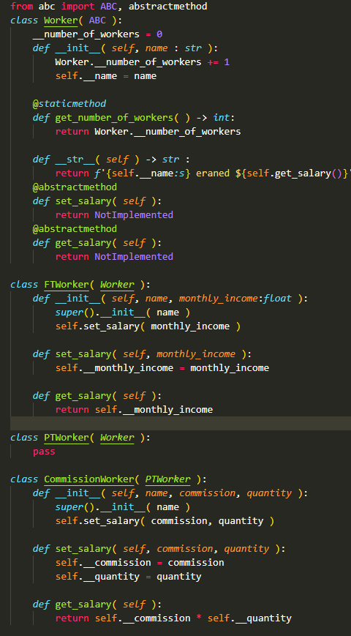
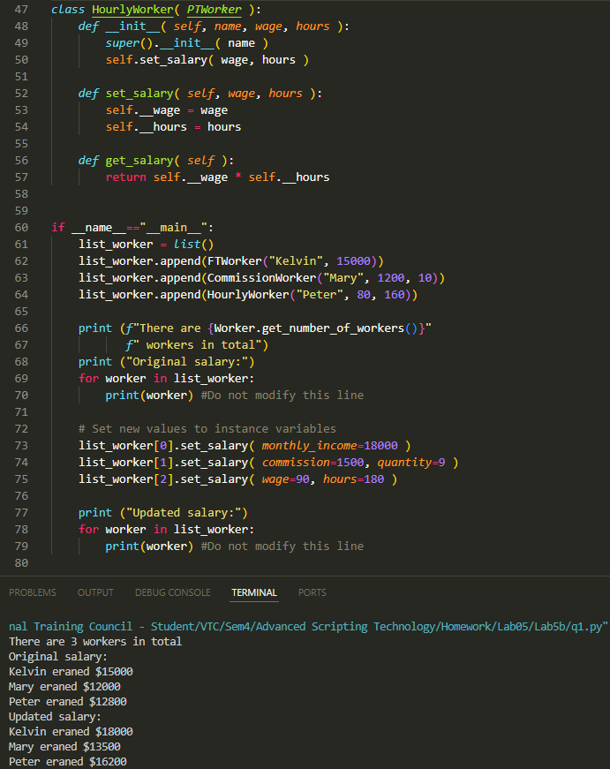

2. Write the supplier classes in the following parts below.
BankAcct

__id : str
__name : str
__transaction_list : list()

__init__ (self, id, name)
get_balance (self) : float
service_charge (self)
deposit (self, amount)
withdraw (self, amount)
display_transaction_history(self)

SavingAcct

NO_OF_FREE_WITHDRAW = 2 : int
AMOUNT_OF_CHARGES = 20 : int
__no_of_withdraw : int

__init__ (self, name)
service_charge (self) : float
withdraw (self, amount)
CurrentAcct

NO_OF_CHARGED_CHEQUE = 2 : int
AMOUNT_OF_CHARGES = 10 : int
__no_of_cheque : int
__init__ (self, name)
service_charge (self) : float
withdraw (self, amount)
Transaction

TYPE = {"DEPOSIT":"deposit",
"WITHDRAW":"withdraw",
"SERVICE":"service charge" }
__type : str
__amount : float
__balance : float

__init__ (self, type, amount, previous_balance)
get_type (self) : str
get_amount (self) : float
get_balance (self) : float

(a) Create an abstract class BankAcct that has:
Attributes:
__id – to store the id of bank account
__name – to store the name of customer
__transaction_list – to store a list of transaction objects of this bank account, which can be used to calculate the balance
Methods:
__init__ – initialize the id and name attribute of bank account object. Initialize the transaction list attribute to an empty list when a bank account object is created
service_charge – an abstract method used to force all child class implement this method. Since calculation of service charges for different account type are different
get_balance – check the number of transaction objects of transaction list in this account first. Return 0 if no transaction is occurred in this bank account before. The balance of this account can be obtained by obtaining the balance of the last transaction record in this account.
deposit – to handle deposit of specified amount of money into bank account. If deposit amount is greater than 0, create a transaction object with deposit type, amount deposit and current account balance and append this transaction object into the transaction list. Else print the failed message.
withdraw – to handle withdraw of specified amount of money from bank account. If withdraw amount is greater than 0 and bank account has enough balance, create a transaction object with withdraw type, amount withdraw and current account balance and append this transaction object into the transaction list. Else print the failed message. Finally, check if the service charge is greater than 0 or not. create a transaction object with service type with the service charge value and add it into the transaction list if service charge is greater than 0
display_transaction_history – to print the transaction history of this bank account. Loop through the transaction list and print the transaction type, amount and balance after each transaction record.
(b) Create a class SavingAcct inherit from class BankAcct that has:
Attributes:
NO_OF_FREE_WITHDRAW – a constant to store the number of free withdrawal without service charge. Assign it to 2 as specified by question.
AMOUNT_OF_CHARGES – a constant to store the amount of charges for every withdrawal afterwards. Assign it to 20 as specified by question.
__no_of_withdraw – an instance variable used to store the number of withdrawal of this account. Used for calculation of service charges.
Methods:
__init__ – initialize the name attribute of saving account object. Super method call is used to call parent class __init__ method to initialize the bank account id and name attribute. Bank account id is a combination of “S” character (means saving account) plus a random integer from 100000 to 999999. Initialize the no_of_withdraw attribute to 0.
service_charge – override the parent class service_charge method to check if current number of withdraw is greater than the number of free withdraw, return the service charge of saving account (i.e. $20) if it is the case. Else return 0.
withdraw – override the parent class withdraw method to count the number of withdrawal additionally. Add 1 to current number of withdraw. Super method call is used to call parent class withdraw method to handle withdrawal of specified amount.
(c) Create a class CurrentAcct inherit from class BankAcct that has:
Attributes:
NO_OF_CHARGED_CHEQUE – a constant to store the number of cheque (withdrawal) that would be charged. Assign it to 2 as specified by question.
AMOUNT_OF_CHARGES – a constant to store the amount of charges for every cheque (withdrawal). Assign it to 10 as specified by question.
__no_of_cheque – an instance variable used to store the number of cheque (withdrawal) of this account. Used for calculation of service charges.
Methods:
__init__ – initialize the name attribute of current account object. Super method call is used to call parent class __init__ method to initialize the bank account id and name attribute. Bank account id is a combination of “C” character (means current account) plus a random integer from 100000 to 999999. Initialize the no_of_cheque attribute to 0.
service_charge – override the parent class service_charge method to check if current number of cheque is smaller than or eques to the number of charged cheque, return the service charge of current account (i.e. $10) if it is the case. Else return 0.
withdraw – override the parent class withdraw method to count the number of withdrawal additionally. Add 1 to current number of cheque. Super method call is used to call parent class withdraw method to handle withdrawal of specified amount.

(d) Create a class Transaction that has:
Attributes:
TYPE – a dictionary constant to store the strings used to distinguish between different transaction type.
__type – an instance variable used to store the string of transaction type. The values should be “DEPOSIT”, “WITHDRAW” or “SERVICE”
__amount – an instance variable used to store the deposit, withdraw or service mount. strings used to distinguish between different transaction type.
__balance – an instance variable used to store the balance of corresponding just after finishing this transaction.
Methods:
__init__ – initialize the type attribute and amount attribute of current transaction object. Initialize the balance of this account by adding or subtracting the transaction amount depending on the transaction type. If the transaction type is deposit, add the amount parameter in this method to the instance balance variable. If the transaction type is withdrawal or service charge, deduct the amount parameter in this method from the instance balance variable.
get_type – getter method used to return the transaction type of current transaction object.
get_amount – getter method used to return the amount of current transaction object.
get_balance – getter method used to return the balance of current transaction object just after finishing this transaction.

(e) Test the above classes with the client / driver program and sample output given below. You are NOT allowed to modify the client / driver program.

if __name__ == "__main__":
list_bankacct = list()
list_bankacct.append(SavingAcct("Kelvin"))
list_bankacct.append(CurrentAcct("Mary"))
list_bankacct[0].deposit(10000)
list_bankacct[1].deposit(8000)
list_bankacct[0].withdraw(12000)
list_bankacct[0].withdraw(7000)
list_bankacct[0].withdraw(3000)
list_bankacct[1].withdraw(1000)
list_bankacct[1].withdraw(2000)
list_bankacct[1].withdraw(3000)

for i in list_bankacct:
i.display_transaction_history()

Sample Output:
Customer Kelvin withdraw 12000 from account S309603 is not successful
Customer Kelvin withdraw 3000 from account S309603 is not successful
Transaction History of Customer Kelvin with Account S309603
Transaction Type | Amount| Balance
deposit | 10000| 10000
withdraw | 7000| 3000
service charge | 20| 2980
Transaction History of Customer Mary with Account C809539
Transaction Type | Amount| Balance
deposit | 8000| 8000
withdraw | 1000| 7000
service charge | 10| 6990
withdraw | 2000| 4990
service charge | 10| 4980
withdraw | 3000| 1980
Note:
- Account ID will be different for every program execution
- Unsuccessful withdrawal also counts for no. of withdraw when calculating service charges
- Withdrawal would be unsuccessful if balance is insufficient for the withdrawal amount together with service charges.
- Service charge will be charged even if the withdrawal is not success.

Answers:
